The Skeleton

**The Skeleton**

The skeleton is the body’s frame and is made up of bones.

The main functions of the skeleton are:

* _________________________________________________________
* _________________________________________________________

**Characteristics of Bones**

Describe the three characteristics of bones and why they need that characteristic.

Bones need to be _________ so they _________________________________________

Bones need to be _________ so they _________________________________________

Bones need to be _________ so they _________________________________________

**Structure of Bones**

Bones are made from two types of tissue. Describe the two types of bone and label them on the picture below.

* _________________________________________________________
* _________________________________________________________

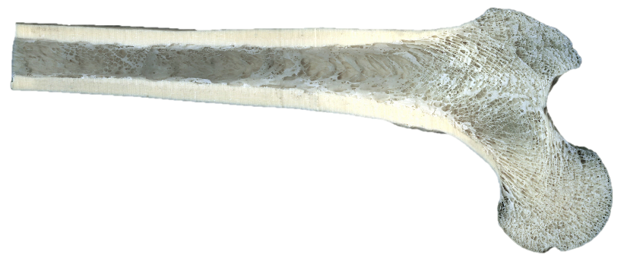

**Parts of the Skeleton**

The skeleton has two main parts, the axial skeleton and appendicular skeleton.

The axial skeleton is ______________________________________________________

The appendicular skeleton is _______________________________________________

Colour the bones of the axial skeleton and appendicular skeleton on the picture on the next page. (Don’t forget to colour the key)

**Major Bones in the Human Body**

Label the major bones in the human body on the skeleton.

|  |  |
| --- | --- |
|  | Axial skeleton |
|  | Appendicular skeleton |

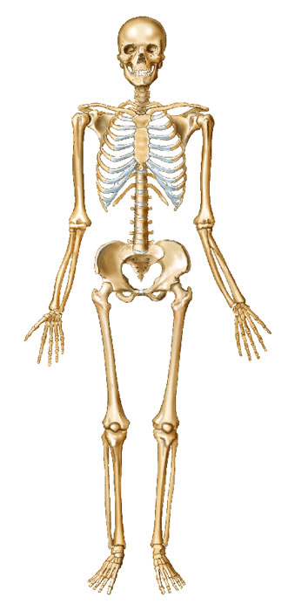

Describe the function of the following bones:

Femur: ________________________________________________________________ _______________________________________________________________________

Skull: __________________________________________________________________ _______________________________________________________________________

Ulna: __________________________________________________________________ _______________________________________________________________________

Ribs: __________________________________________________________________ _______________________________________________________________________